**Submit before 30th Sep to earn 100 points**

PRO-C24: CRUMPLED BALLS - 1

Assigned

**INSTRUCTIONS:**

**Goal of the Project:**

In Class 24, you learnt how to create various bodies and assign different properties to them.  
  
In this project, you will have to practice and apply what you have learnt in the class and ign the elements of a simple game of throwing crumpled paper balls in a waste paper basket.

** This project is dependent on the concepts covered in Project 23. Please complete project 23 before attempting this project.

**Story:**

You want to inculcate the habit of throwing the waste in the trash bin in young individuals and help keep your city clean. So you have decided to create a simple game of throwing crumpled paper balls in a waste paper basket.  
  
See a video of this in action [here](https://www.youtube.com/watch?v=D2ck-aT5ORg&feature=youtu.be)  
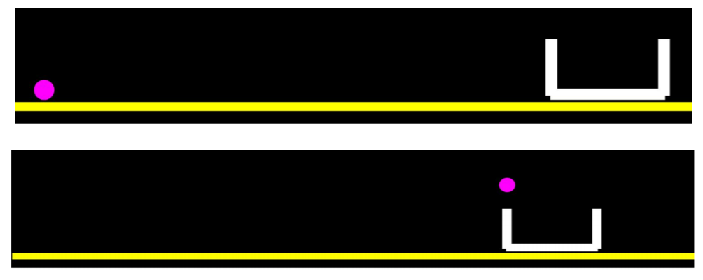

*This is just for your reference. We expect you to apply your own creativity in the project.

**Getting Started:**

1. Use the template on github, available for download on the following link:

<https://github.com/rupinwhitehatjr/MatterJSBoilerPlate/archive/master.zip>

1. **Unzip** this folder.
2. Rename the unzipped folder as **Project 24**.
3. **Import** this folder **into VS Code**.
4. Start editing your code in **sketch.js.**.

**Specific Tasks to complete the Project:**

Create a blueprint for the **paper class**.

* + This object will be the moving object in the game.
  + For this project, a circle will suffice.
  + Make sure you set the **density** of the paper to **1.2** as shown below.

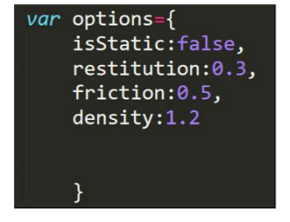

1. Create a **dustbin class**.
   * The dustbin class will be similar to the bucket/container that you have created in Project 23 (Supply Mission-2).
2. Create a blueprint for the **Ground**, on which the dustbin stands and the crumpled paper ball may fall on.
3. Make the crumpled paper **jump and fall** into the bucket with the **up arrow key**.(See hints below on how to do this)
4. Make sure the project works before you submit it.

*Refer to the images given above for reference.

**Submitting the Project:**

1. **Upload** your completed project to your own github account.
2. Enable **Github** pages for the repository.
3. Copy and paste the link to the github pages in the Student Dashboard against the correct class number.

**Hints:**

1. The crumpled paper object will have a circular body. Remember, in p5.js use the ellipse method to create the circle.<https://p5js.org/reference/#/p5/ellipse>
2. In Matter.js use the Matter.Bodies.circle to create a circular body.<https://brm.io/matter-js/docs/classes/Bodies.html#method_circle>

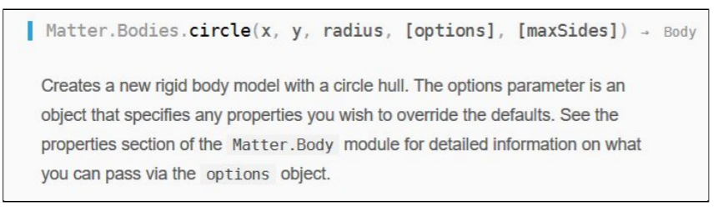

1. Circles in p5.js and circles in matter.js behave a little differently. The p5.js expects the  
   third parameter to be a radius, but the matter.js will expect a diameter. Make sure you do this correctly.
2. To make an object jump, you have to apply a force to an object.
   * Use the **Matter.Body.applyForce** method: <https://brm.io/matter-js/docs/classes/Body.html#method_applyForce>

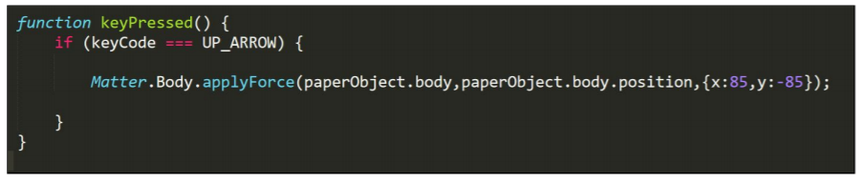

**REMEMBER… Try your best, that’s more important than being correct.**

After submitting your project your teacher will send you feedback on your work.